|  |
| --- |
|  |

1. Add gender column for the student table. It holds two value (male or female).

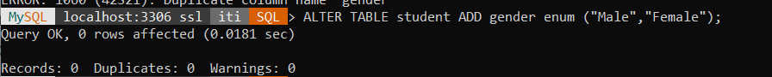

2. Add birth date column for the student table.



3. Delete the name column and replace it with two colums first name and last name.

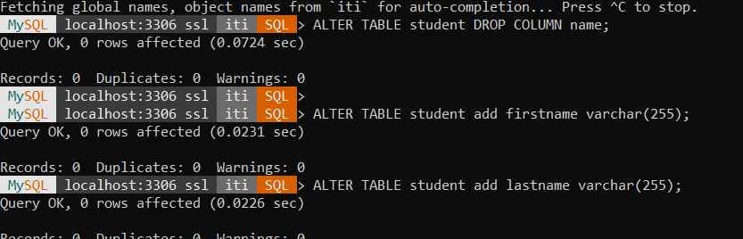  
4. Delete the address and email column and replace it with contact info (Address, email)  
as object Data type.

5. Add foreign key constrains in Your Tables with options on delete cascaded .



6. Update your information by changing data for (gender, birthdate, first name, last name, contact info).



7. Display all students’ information.

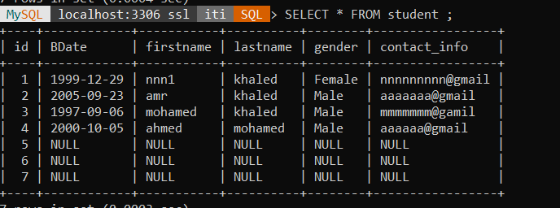

8. Display male students only.

9. Display the number of female students.

10. Display the students who are born before 1992-10-01.

11. Display male students who are born before 1991-10-01.

12. Display subjects and their max score sorted by max score.

13. Display the subject with highest max score

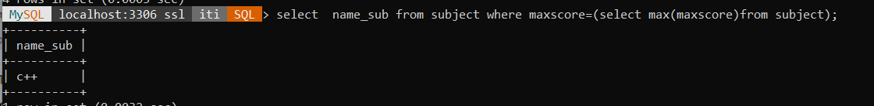

14. Display students’ names that begin with A.

15. Display the number of students’ their name is “Mohammed”

16. Display the number of males and females.

17. Display the repeated first names and their counts if higher than 2.

  
18. Display students’ names, their score and subject name.

  
19. Delete students their score is lower than 50 in a particular subject exam.  
